1. 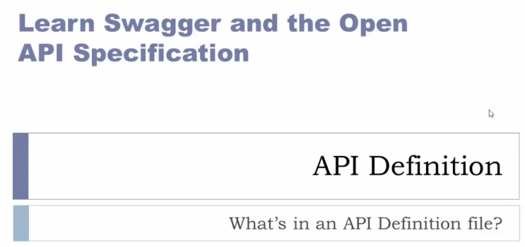
2. **Agenda**:

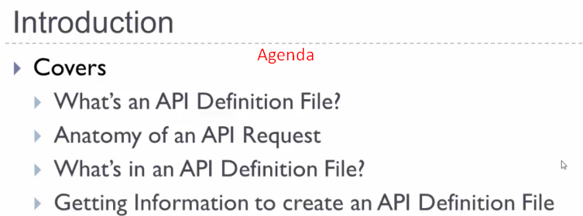

1. **What is an API Definition File**?”  
   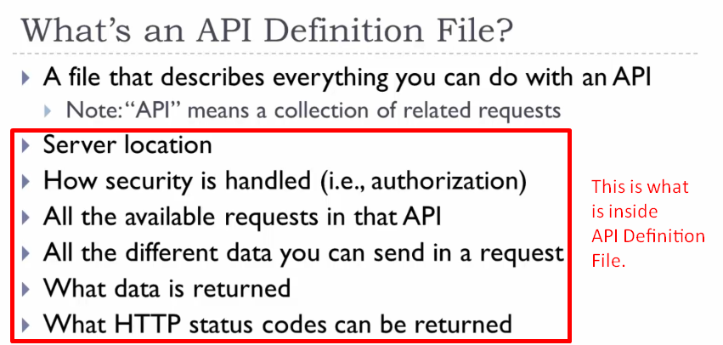
   1. Sometimes, you’ll hear people refer to an individual request as an API.  
      But I will always use it to mean a group of requests.
2. The Anatomy of a Request.